6.70: a) This is similar to Problem 6.64, but here 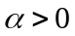 (the force is repulsive), and 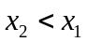, so the work done is again negative;
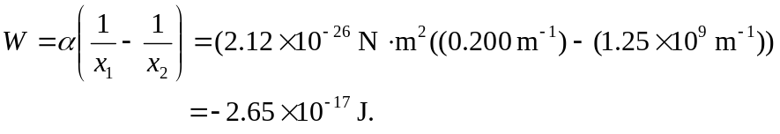
Note that  is so large compared to 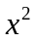 that the term 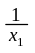 is negligible. Then, using Eq. (6.13)) and solving for 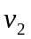,
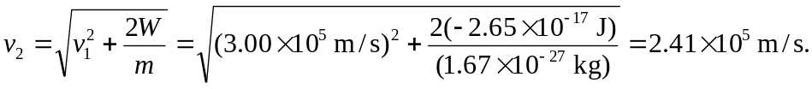
b) With 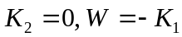. Using 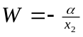,
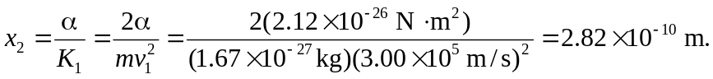
c) The repulsive force has done no net work, so the kinetic energy and hence the speed of the proton have their original values, and the speed is 

